CHEM-115 Quiz 8 (Chapter 15) November 17, 2017

Name: ___________________________
- Which of the following is an incorrect statement of the differences between RNA and DNA?
- DNA is double stranded; RNA is single-stranded
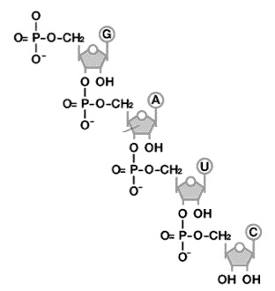
- DNA contains thymidine; RNA contains uracil
- DNA contains ribose; RNA contains deoxyribose
- DNA is highly stable; RNA degrades rapidly

- On the nucleic acid diagram to the right:

  - Identify whether this is: RNA or DNA
(circle one)

  - Put a circle around the 5’ end

  - Put a box around the 3’ end

For a given DNA sequence, answer the following questions. You may use the chart to the right to help you identify the genetic code.

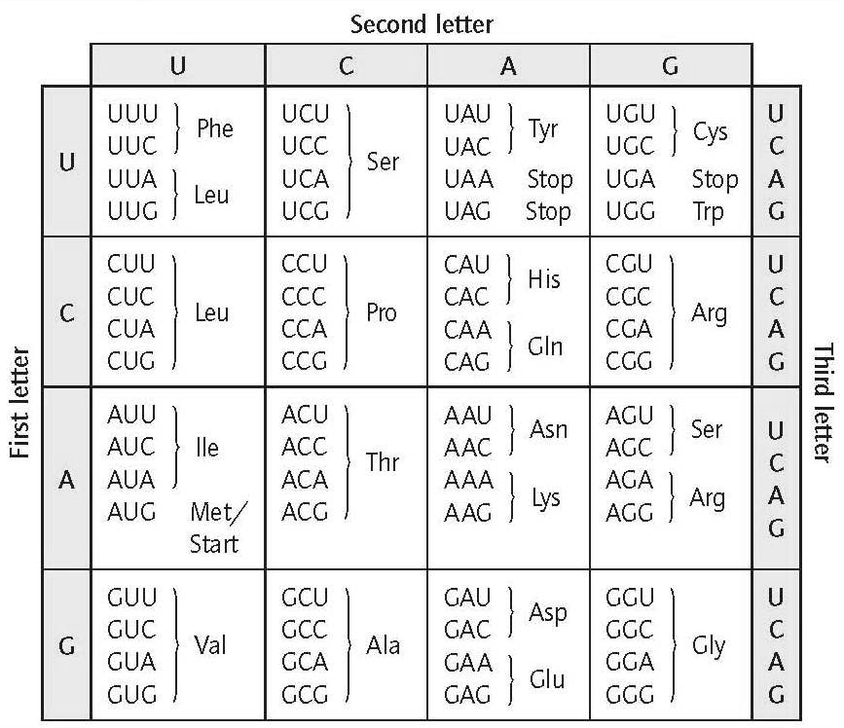
- Fill in the complementary mRNA sequence to the DNA strand below, assuming that the bottom strand is the template strand for transcription:

5’-GATGGAATTTAGACCTACGC-3’
3’-CTACCTTAAATCTGGATGCG-5’

mRNA 5’ _________________________________3’

- Indicate the peptide sequence encoded by this mRNA strand. You should identify the ‘reading frame’ by identifying a start codon.

___________________________________

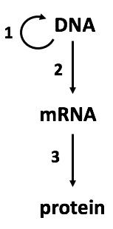
- On the diagram to the right:

  - Which process would involve a ribosome? _______

  - Which processes require a polymerase? ______ & ______

  - Which process depicts replication? ______

CHEM-115 Quiz 8 (Chapter 15) November 17, 2017

Name: ___________________________

For a given DNA sequence, answer the following questions. You may use the chart to the right to help you identify the genetic code.

- Fill in the complementary mRNA sequence to the DNA strand below, assuming that the bottom strand is the template strand for transcription:
5’-GATGGAATTTAGACCTACGC-3’
3’-CTACCTTAAATCTGGATGCG-5’

mRNA 5’ _________________________________3’

- Indicate the peptide sequence encoded by this mRNA strand. You should identify the ‘reading frame’ by identifying a start codon.

___________________________________
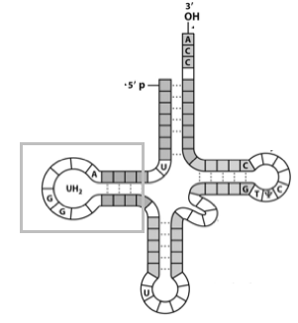

- On the tRNA diagram to the right:

  - Put a circle around the location of the anticodon

  - Put a box around the location to which an amino acid
would connect to the tRNA

c) What kind of RNA structure is depicted in the gray box?

- Which of the following is an incorrect statement of the differences between RNA and DNA?
- DNA is double stranded; RNA is single-stranded
- DNA contains thymidine; RNA contains uracil
- DNA contains ribose; RNA contains deoxyribose
- DNA is highly stable; RNA degrades rapidly

- On the nucleic acid diagram to the right:

  - Identify whether this is: RNA or DNA
(circle one)

  - Put a circle around the 5’ end

  - Put a box around the 3’ end

